D3.8

Development of the Refurbishment Ecosystem based on an APM and definition of data management

|  |  |  |  |  |  |  |  |
| --- | --- | --- | --- | --- | --- | --- | --- |
| D3.8 | | Work Package No. | WP3 | | Task/s No. | Task 3.3 | |
| Work Package Title | COLLABORATIVE REFURBISHMENT ECOSYSTEM BASED ON AGILE PROJECT MANAGEMENT TOOLS | | | | | | |
| Linked Task/s Title | DEVELOPMENT OF THE REFURBISHMENT ECOSYSTEM BASED ON AN AGILE PROJECT MANAGEMENT TOOL AND DEFINITION OF DATA MANAGEMENT | | | | | | |
| Status |  | | |  | | | |
| Dissemination level | Co-Confidential | | | (PU-Public, PP, RE-Restricted, CO-Confidential) | | | |
| Due date deliverable | M20 | | | Submission date | | | M20 |
| Deliverable version | 1 | | | | | | |
|  |  |  |  |  |  |  |  |

Document Contributors

|  |  |  |  |  |
| --- | --- | --- | --- | --- |
| **Deliverable responsible** | | ESTIA | | |
| **Contributors** | Organization | | **Reviewers** | Organization |
| Maxime Daniel | ESTIA | |  |  |
| Dimitri Masson | ESTIA | |  |  |
|  | RIMOND | |  |  |
| Laura Laguna Salvado | ESTIA | |  |  |
| Eric Villeneuve | ESTIA | |  |  |

Document History

|  |  |  |
| --- | --- | --- |
| Version | Date | Comment |
| 1.0 | 2019-06-30 | D3.8 MVP |

Table of contents

1. EXECUTIVE SUMMARY 4

2. INTRODUCTION 4

2.1. Purpose 4

# EXECUTIVE SUMMARY

The aim of this document is to submit the first version of the Collaborative Refurbishment Platform (CRP) as a minimum viable prototype.

This document includes the links to the Source Code, the online CRP and the Docker.

This document has been elaborated by ESTIA based on D1.2 and in collaboration with RIMOND.

# PURPOISE

One of the main objectives of the REZBUILD project is to create an Ecosystem which contributes on the integration of stakeholders and tools all along the supply chain in order to improve NZEB refurbishment projects.

The Ecosystem, as defined by the Consortium, consists on a data and project management hub.

On this Task, ESTIA develops the core part of this Ecosystem called the Collaborative Refurbishment Platform (CRP), based on WP1 requirements. The CRP aims to facilitate data exchange, decision making and coordination amongst stakeholders with an integrated approach along the supply chain.

At the beginning of the Project, the efforts have been focused on the construction of a Data Management Plan based on the Consortium vision of the Collaborative Refurbishment Platform.

Then, ESTIA has started the development of the MVP (Minimum Vital Prototype) of the CRP, which is shared with this deliverable.

# The Collaborative Refurbishment Platform MVP

# Main Functionalities

This Deliverable consists on the development of the CRP. The development of the REZBUILD CRP is addressed by ESTIA with an Agile software development methodology.



Figure 1 Full Stack Web Architecture of the CRP

The CRP is a Full Stack Web Plateform using the MERN stack (Figure 1) and composed of three parts:

* *A Web Client Application (****APP****) using the API.*
* A Web Application Protocol Interface (**API**) following the Create, Retrieve, Update, Delete *philosophy (CRUD) for the DB.*
* A DataBase **(DB**)

The functionalities (assimilated to user stories) are aligned with the specifications defined on D1.2. The CRP three main functionalities developed in the CRP MVP are:

* BIM centred collaboration: One of the REZBUILD project innovations is the development of a building model centred CRP. All the refurbishment project related data can be gathered/referred on a single BIM (Building Information Model) file. In the CRP, Stakeholders can visualize the BIM, integrate their contributions and export data generated previously, always associated to the BIM. This functionality is possible thanks to D3.7 (RIMOND) and integrated on this deliverable as main data flow of the CRP.
* Refurbishment Technologies Library: REZBUILD project aims at testing and upgrading innovative technologies. The CRP therefore hosts a Refurbishment Technology Library, as a support for Designers and other stakeholders in decision making processes. This library can be exploited by Refurbishment Ecosystem tools.
* Agile Project Management: In line with the REZBUILD objective of reducing the refurbishment project lead time, stakeholders can manage/follow the refurbishment project through an Agile Management Tool. Agile Management permits advancement of project tasks without the classical project management approach constraints (pre-defined project plan).

Table - User Stories developed on D3.8

|  |  |  |  |
| --- | --- | --- | --- |
| **#** | **User Story title** | **Persona** | **Priority** |
| 1 | New Project | Olivier | *** |
| 2 | Assign Pre Assessment Task | Olivier | *** |
| 3 | Join an Existing Project | Alice | *** |
| 4 | Perform a Pre Assessment | Alice | *** |
| 5 | Select an Insulating Material | Alice | *** |
| 6 | Model Existing Building | Alice | *** |
| 7 | Use openBIM library for advanced tech | Alice | *** |
| 8 | Submit a proposal | Alice | *** |
| 9 | Create LCA Task | Alice | *** |
| 10 | Perform LCA Task | Christophe | *** |
| 11 | Project Inspection | Olivier | *** |

In addition, ESTIA is working on decision making support tools to be integrated in the Ecosystem. This development should facilitate multicriteria decision making during refurbishment projects, especially during the design phases.

# User Interface

The figures 2-9 illustrate the different web pages of the CRP.

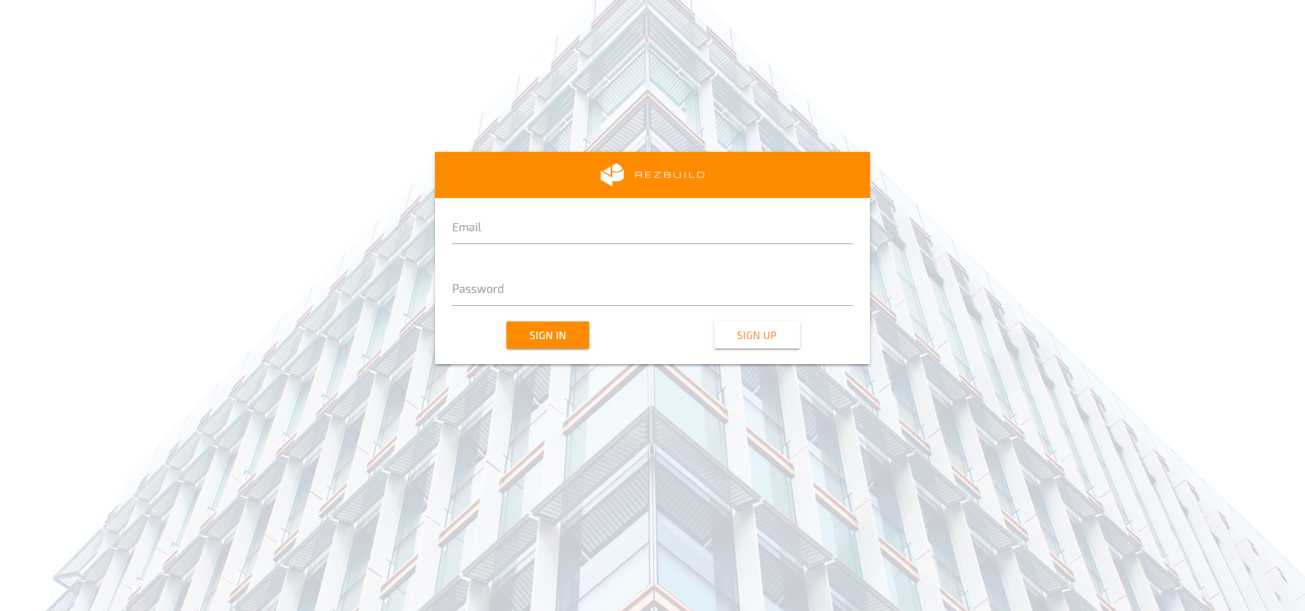

Figure 2 Signin Page

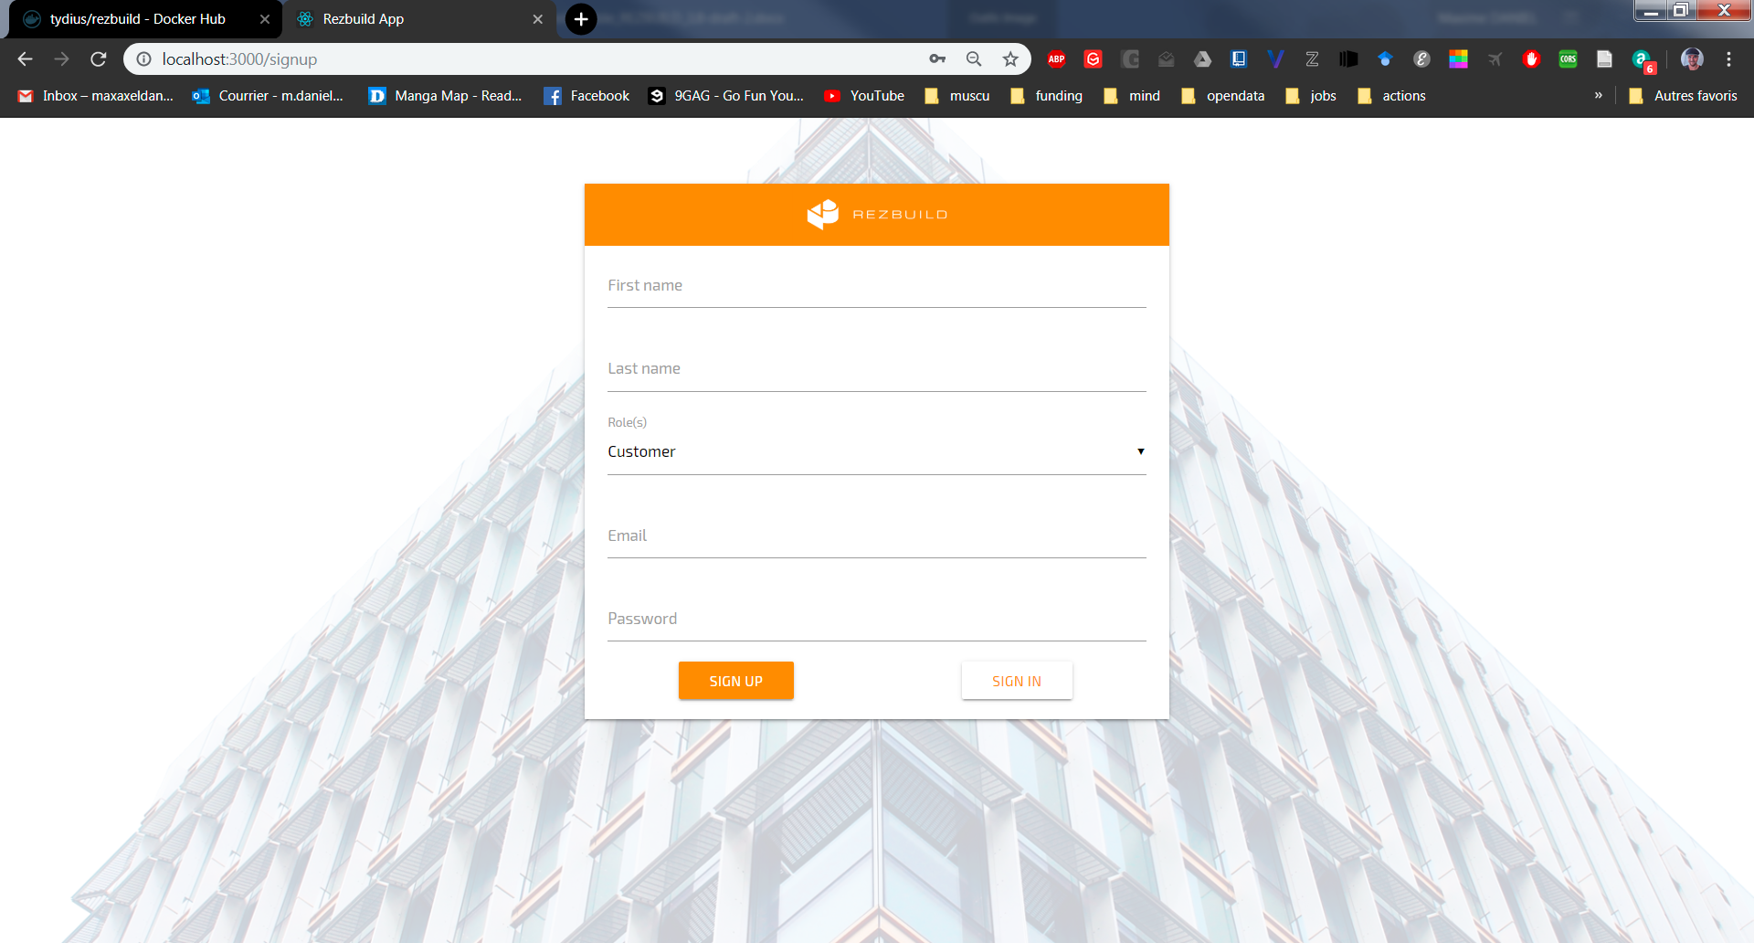

Figure 3 Signup Page

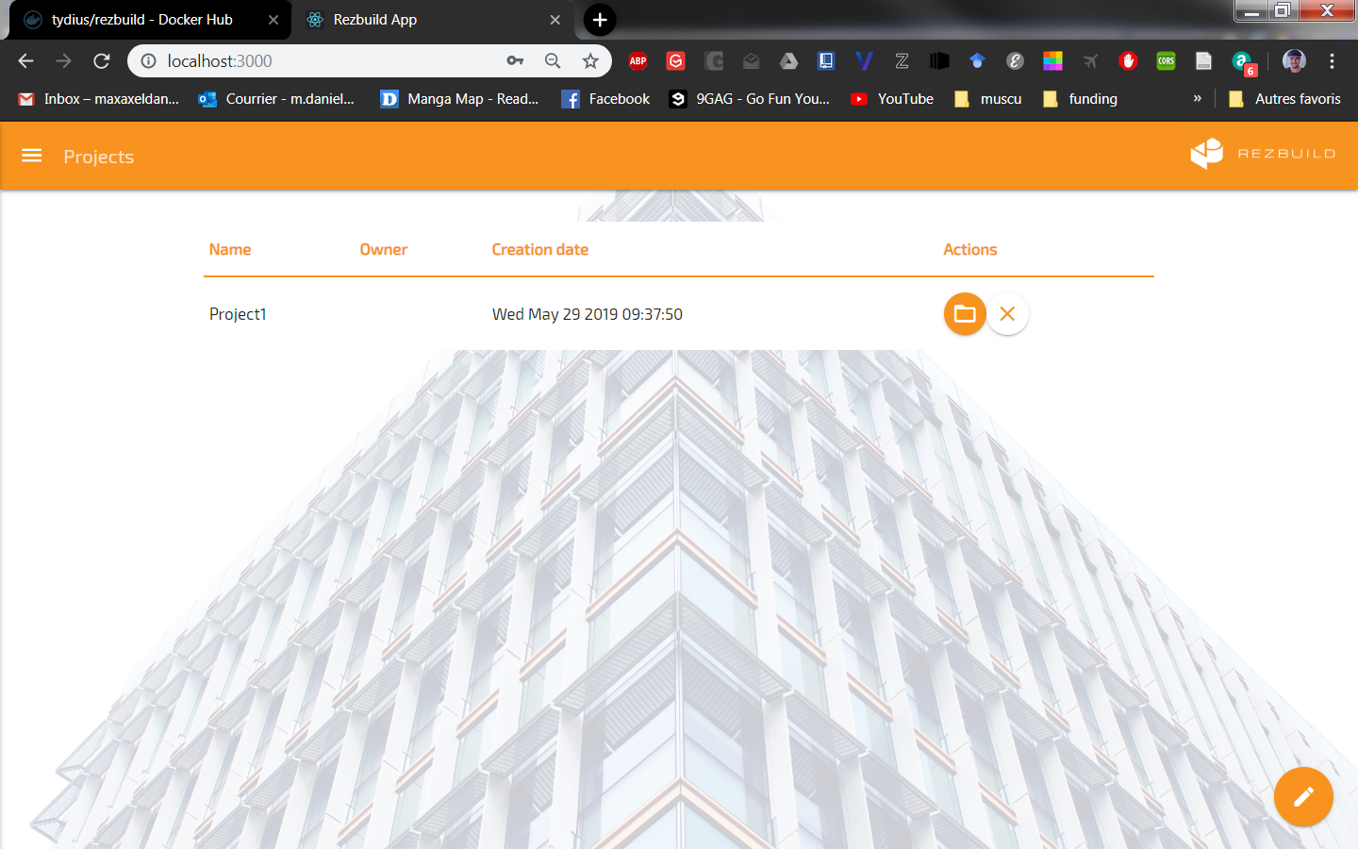

Figure 4 Project List Page

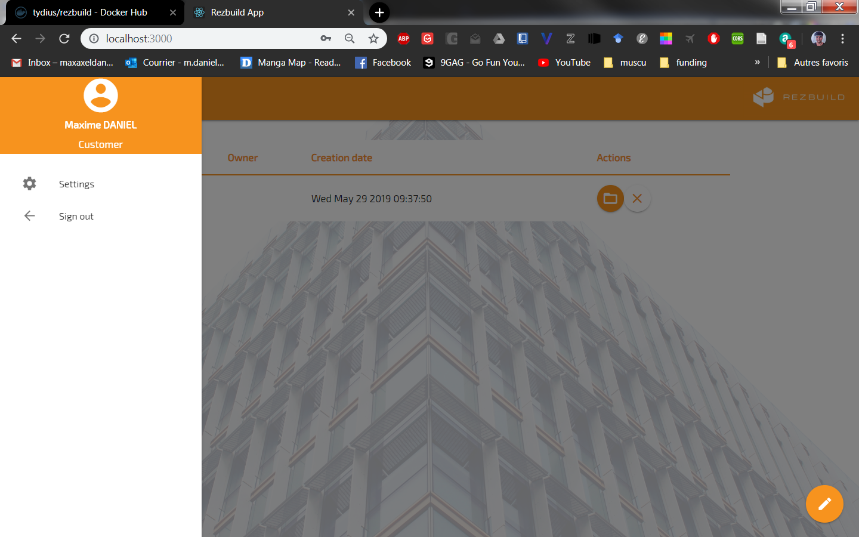

Figure 5 Profil Page

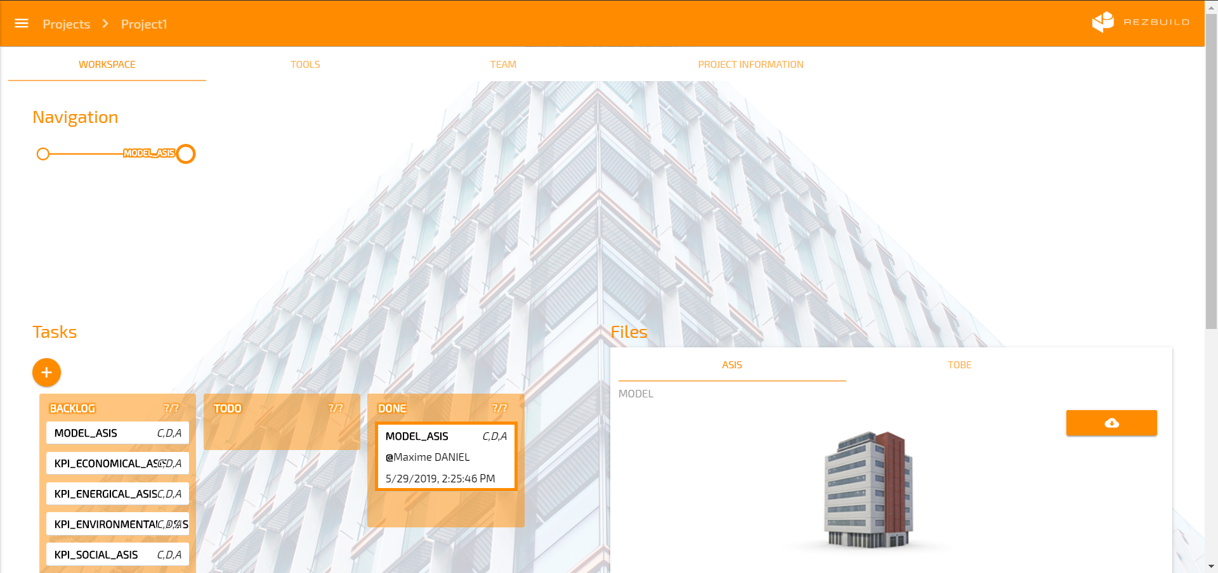

Figure 6 Workspace Page

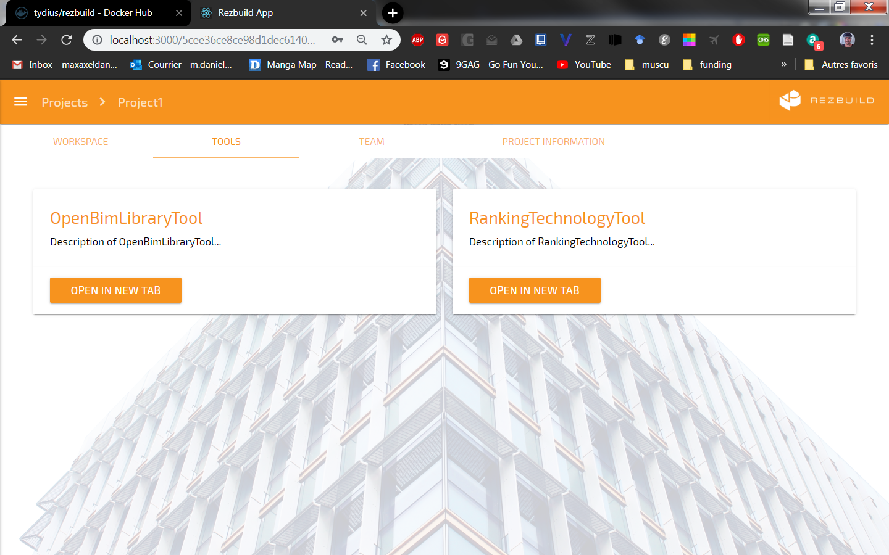

Figure 7 Tools Page

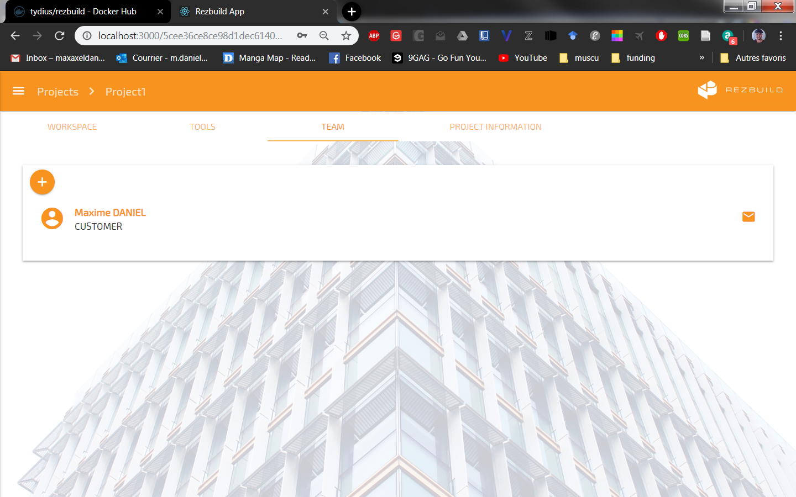

Figure 8 Team Page

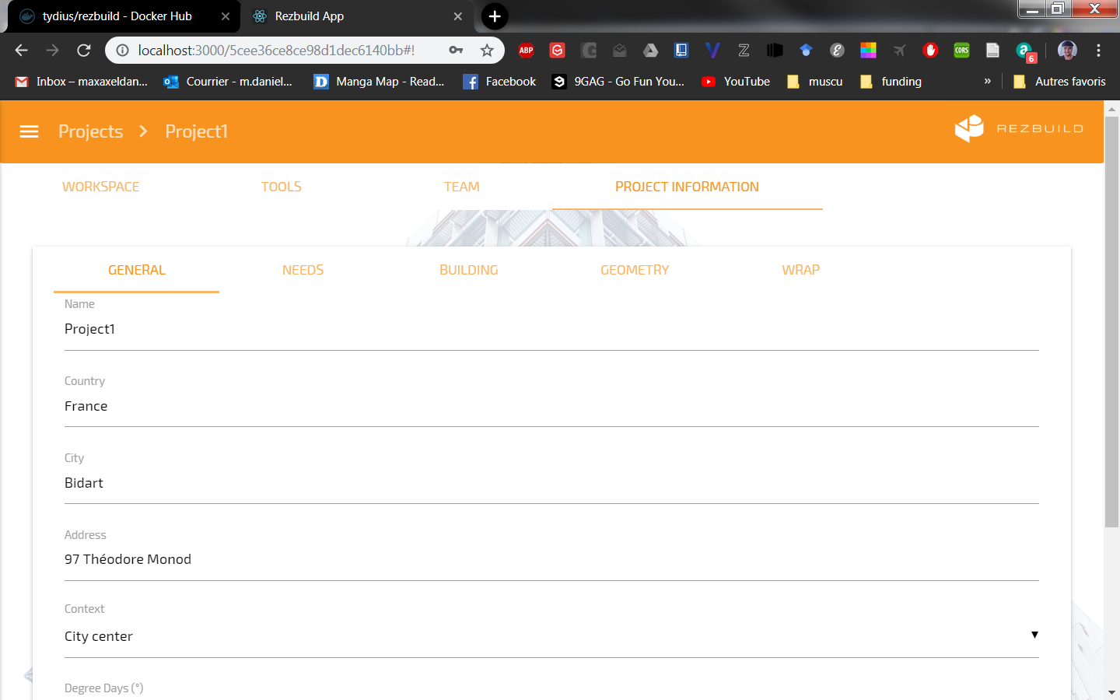

Figure 9 Project Information Page

# Links to the CRP



Figure 10 - Deployment Flow of the CRP

The Figure 10 describes the deployment flow of the CRP.

1. The source code of the CRP (APP, API, DB) is hosted on Github**:** <https://github.com/maximedaniel/rezbuild>
2. The docker image of the source code is built on DockerHub**:**

<https://hub.docker.com/r/tydius/rezbuild>

1. They docker image runs on ESTIA:

<https://rezbuildapp.estia.fr/>

# Future steps

The outcomes of this Deliverable will be tested by all Consortium members, and by all the demosites. This should allow an incremental improvement of functionalities.